Name:________________ Date:_____________

The table below is from a sample of SBP of kids who are average height.

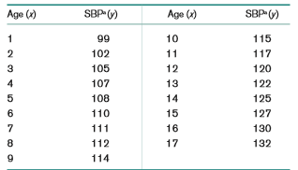

**Input the data above into SAS.**

**Question 1**. Run a linear regression model to determine relating age to Systolic Blood Pressure. Paste output here (Analysis of Variance and Parameter estimate tables).

**Question 2.** Provide an interpretation of the parameter estimate for age.

**Question 3.** Provide an interpretation of the parameter estimate for the intercept.

**Question 2**. Test for the statistical significance of this regression line using the F test. What is the F-test statistics?

**Question 3**. What is the p-value from the F-test statistics?

**Question 4**. What is the conclusion for based on the p-value from the F test?

**Question 5**. Test for the statistical significance of the regression line using the t-test. What is the t-test statistics?

**Question 6**. What is the p-value from the t-test statistics?

**Question 7**. What is the conclusion for based on the p-value from the t test?

**Paste code here.**